Bài 2:

1.a/ Thiết lập mô hình mạng:

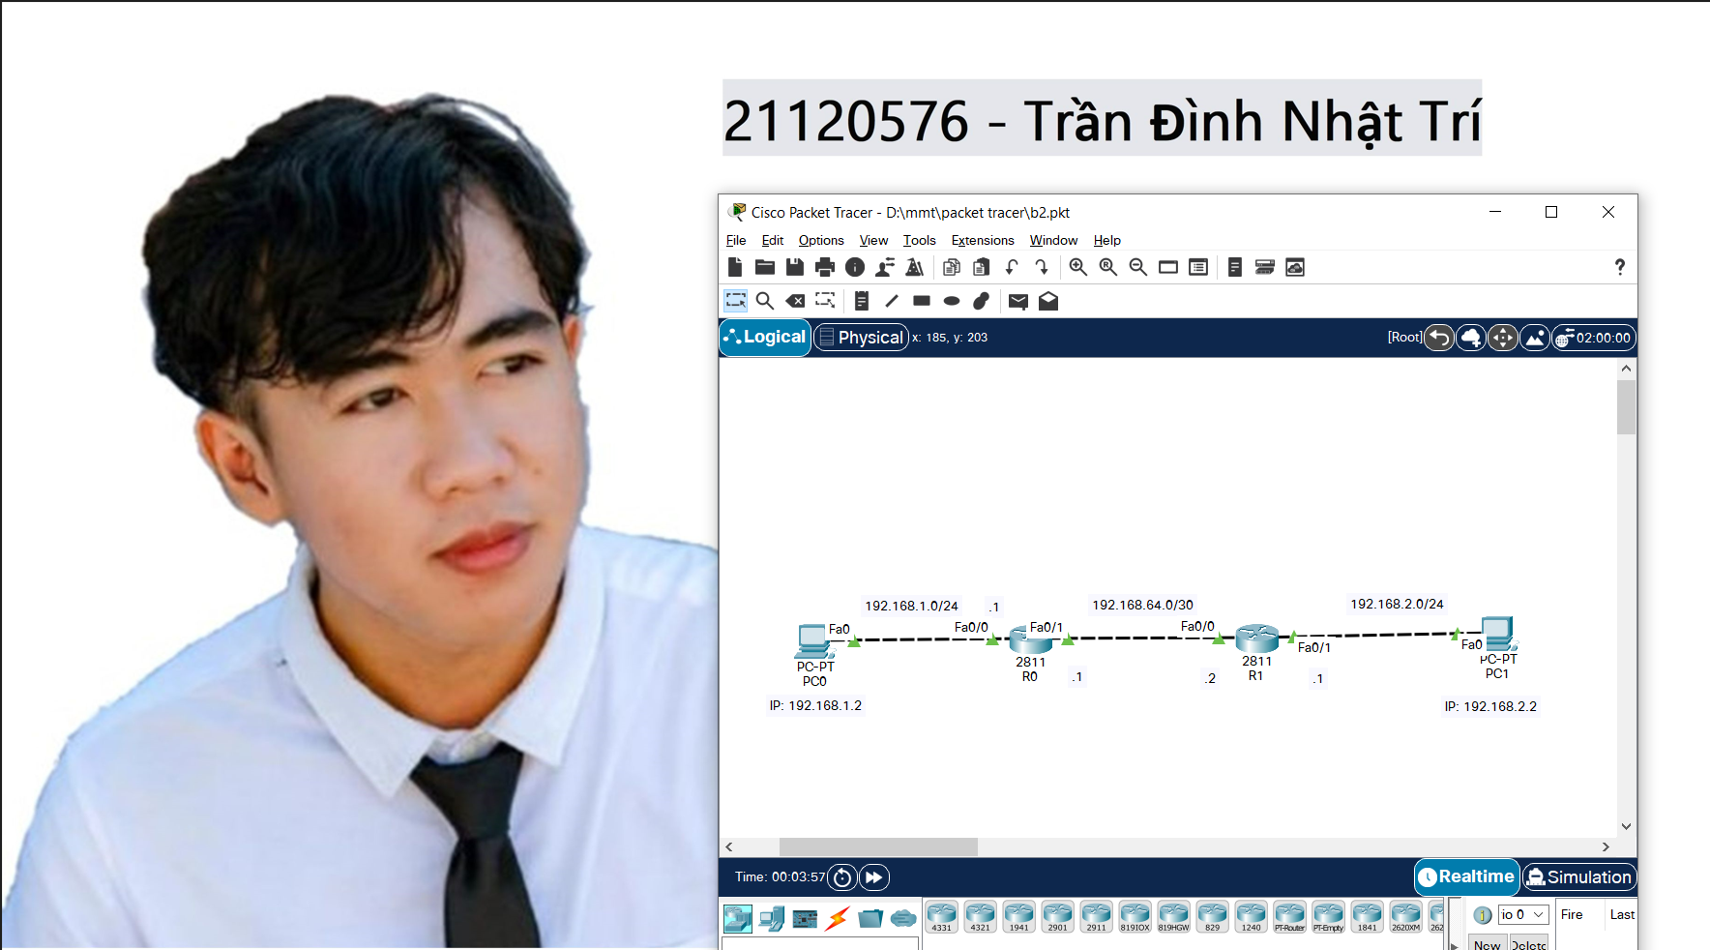

1.b/ Cấu hình địa chỉ IP:

* Cấu hình cho máy tính:

|  |  |  |
| --- | --- | --- |
| Cấu hình | PC0 | PC1 |
| IP | 192.168.1.2 | 192.168.2.2 |
| Subnet | 255.255.255.0 | 255.255.255.0 |
| MAC | 0090.0C25.5AD1 | 00E0.A3AC.B691 |
| Gateway | 192.168.1.1 | 192.168.2.1 |

* **PC0:**

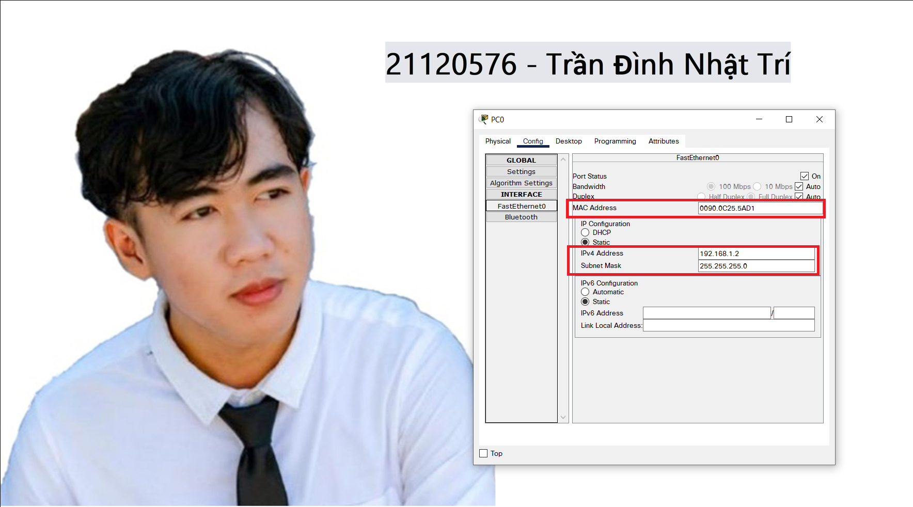

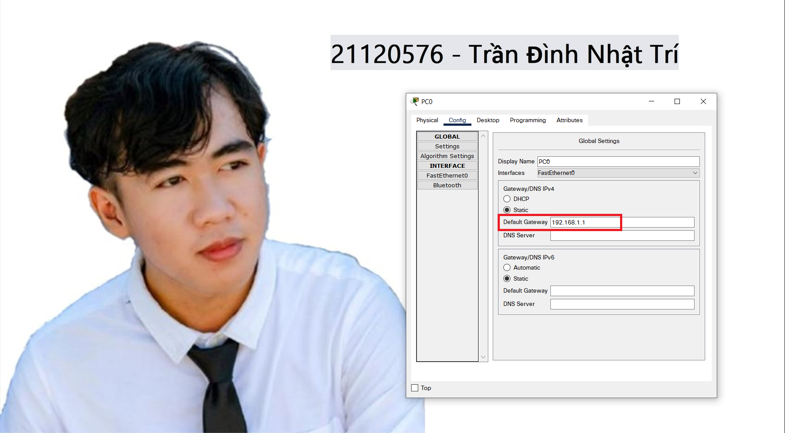

* **PC1:**

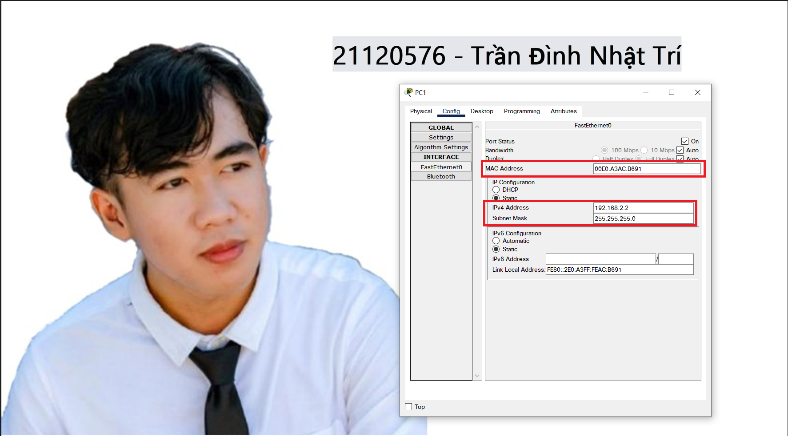

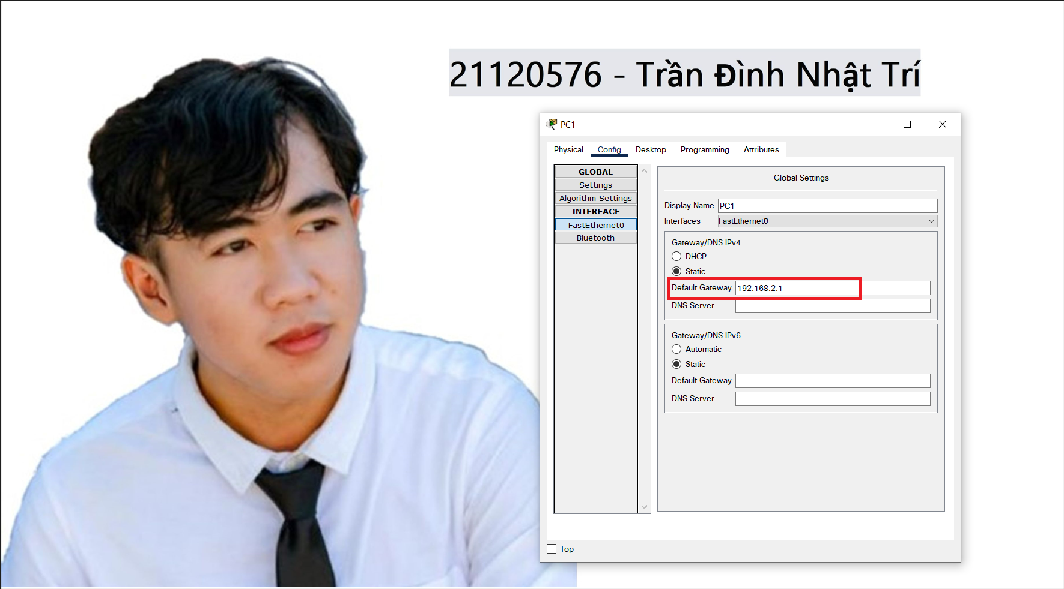

* Cấu hình cho router:
* R0:

|  |  |  |  |
| --- | --- | --- | --- |
| INTERFACE | IP | Subnet | MAC |
| Fa0/0 | 192.168.1.1 | 255.255.255.0 | 0007.ECE0.B701 |
| Fa0/1 | 192.168.64.1 | 255.255.255.252 | 0007.ECE0.B702 |

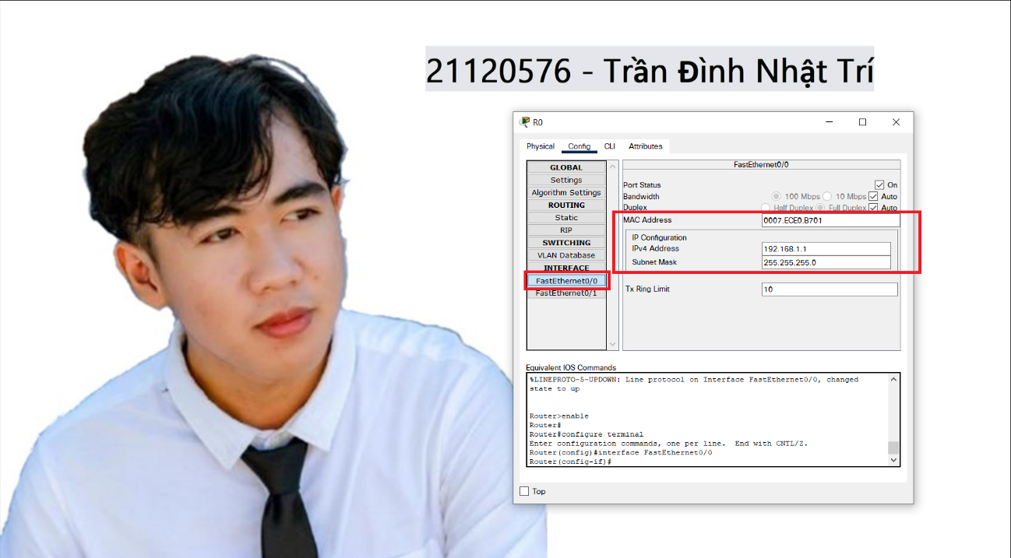

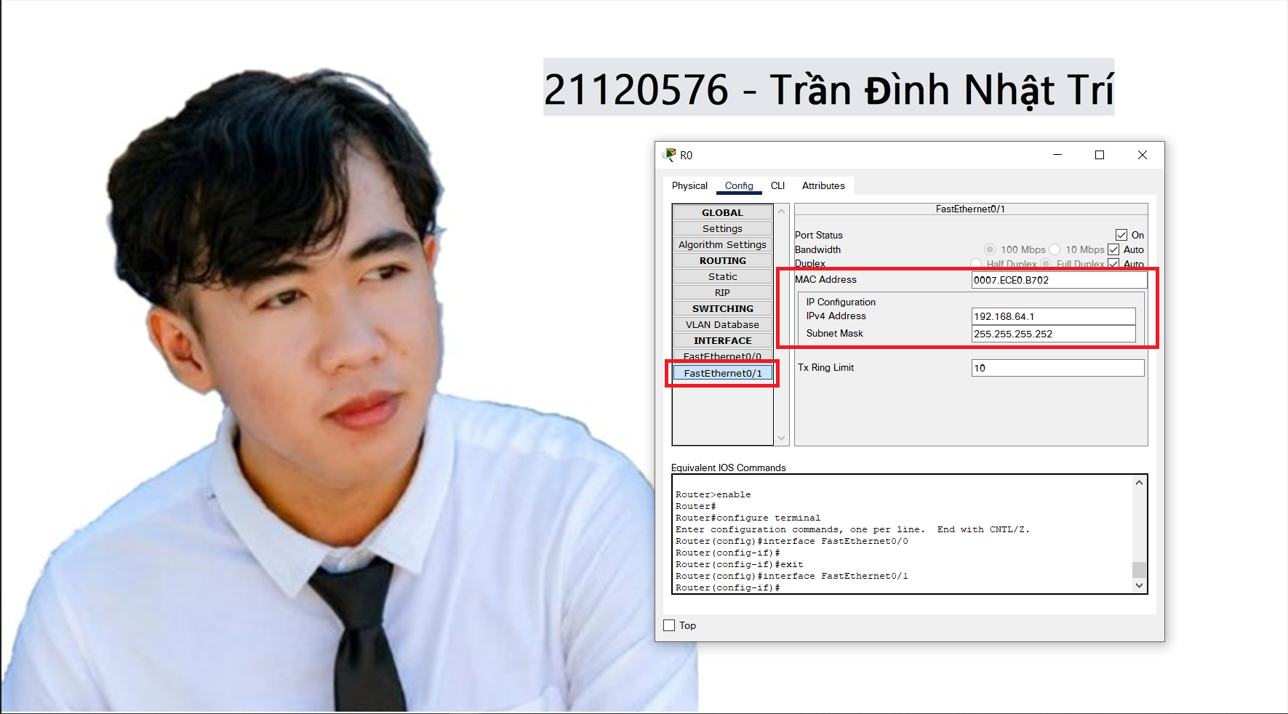

* R1:

|  |  |  |  |
| --- | --- | --- | --- |
| INTERFACE | IP | Subnet | MAC |
| Fa0/0 | 192.168.64.2 | 255.255.255.252 | 0002.1791.1201 |
| Fa0/1 | 192.168.2.1 | 255.255.255.0 | 0002.1791.1202 |

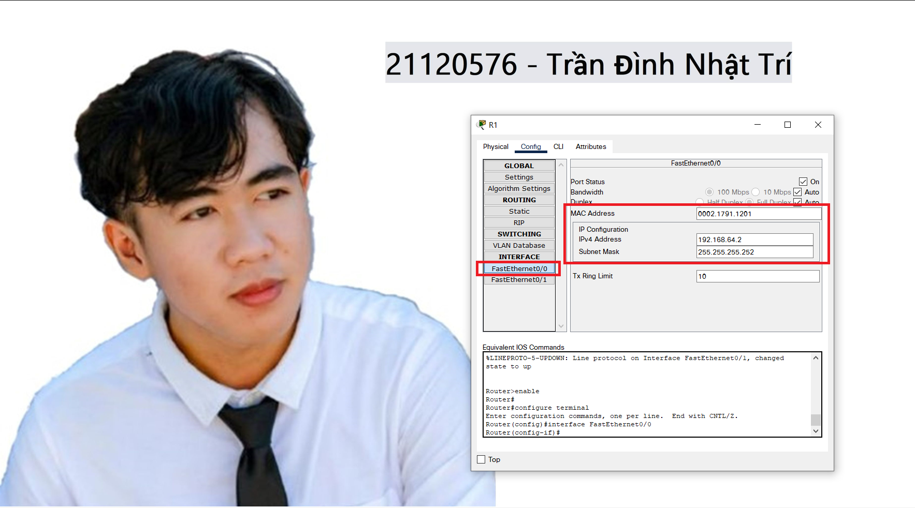

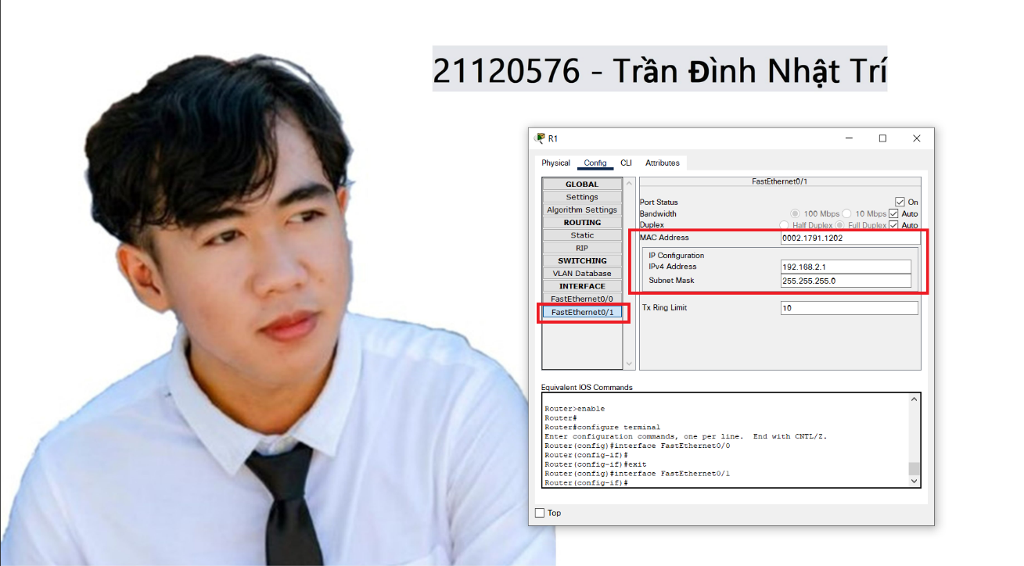

**1**.c/ Định tuyến: 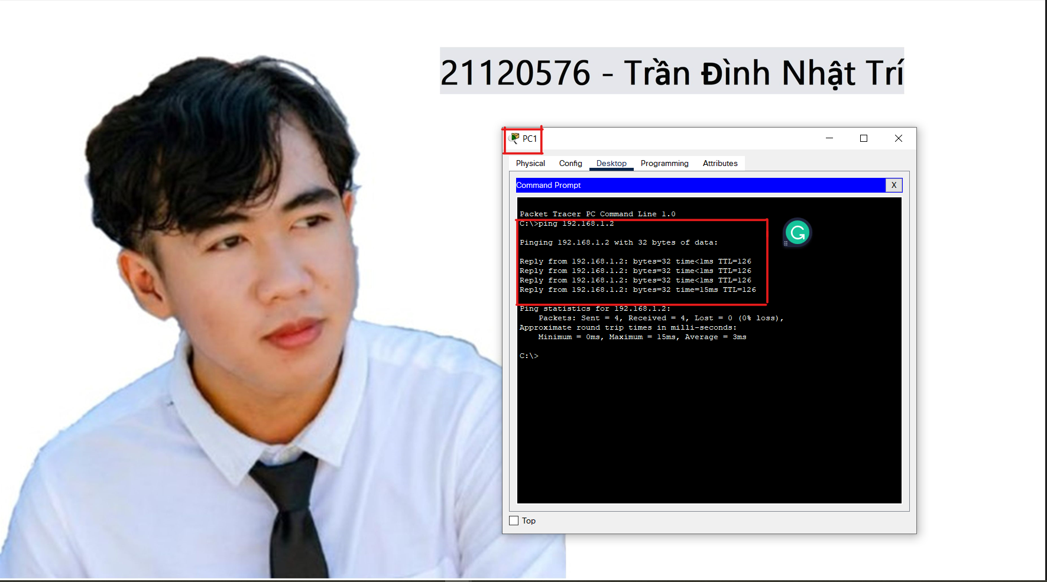

**2.**

|  |  |  |  |  |
| --- | --- | --- | --- | --- |
| **Giai đoạn** | **IP Nguồn** | **IP Đích** | **MAC Nguồn** | **MAC Đích** |
| PC0 -> R0 | 192.168.1.2 | 192.168.2.2 | 0090.0C25.5AD1 | 0007.ECE0.B701 |
| R0 -> R1 | 192.168.1.2 | 192.168.2.2 | 0007.ECE0.B702 | 0002.1791.1201 |
| R1 -> PC1 | 192.168.1.2 | 192.168.1.2 | 0002.1791.1202 | 00E0.A3AC.B691 |
| PC1 -> R1 | 192.168.2.2 | 192.168.1.2 | 00E0.A3AC.B691 | 0002.1791.1202 |
| R1 -> R0 | 192.168.2.2 | 192.168.1.2 | 0002.1791.1201 | 0007.ECE0.B702 |
| R0 -> PC0 | 192.168.2.2 | 192.168.1.2 | 0007.ECE0.B701 | 0090.0C25.5AD1 |

* **PC0 (0.000):**

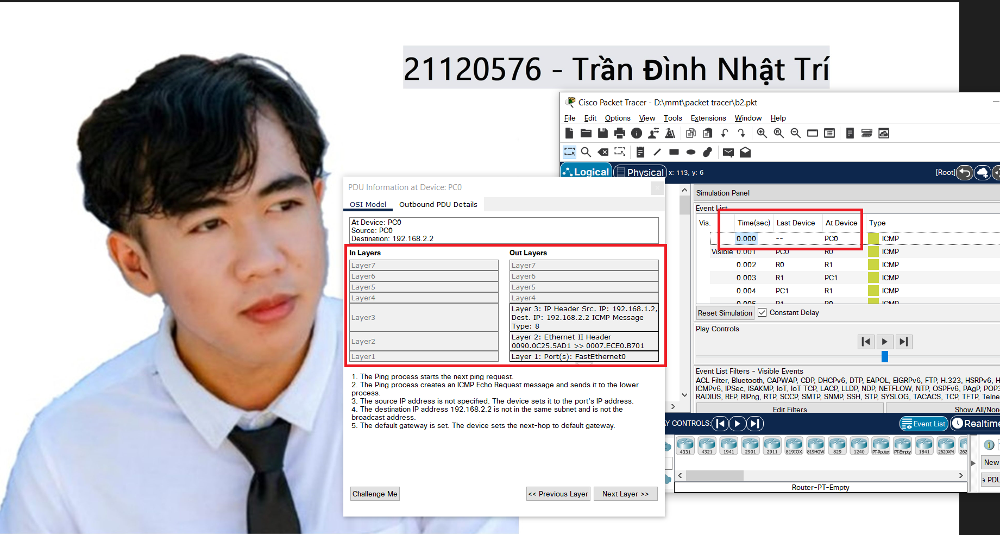

* **PC0 -> R0 (0.001):**

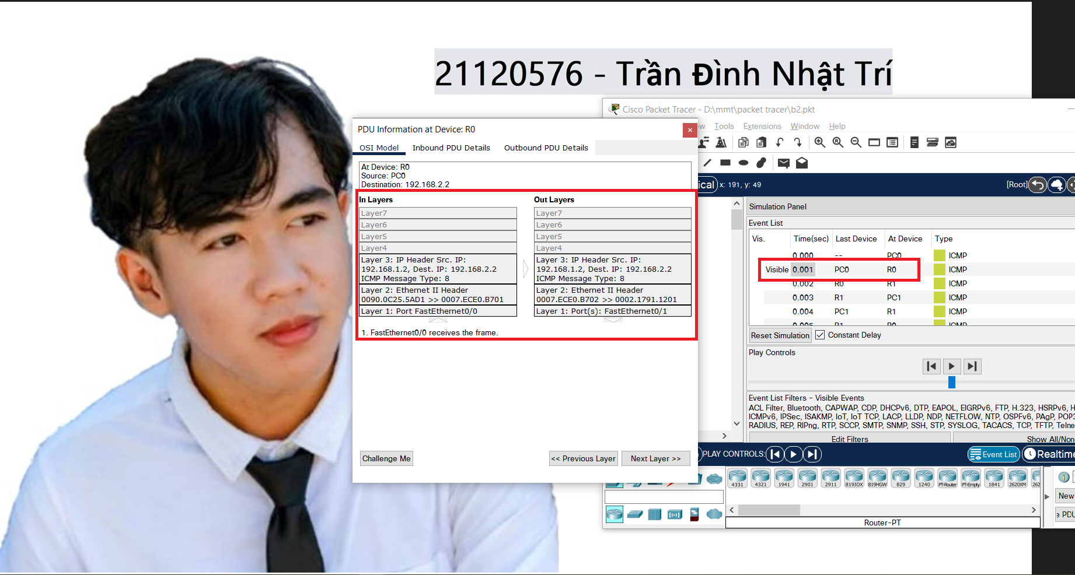

* **R0 -> R1 (0.002):**

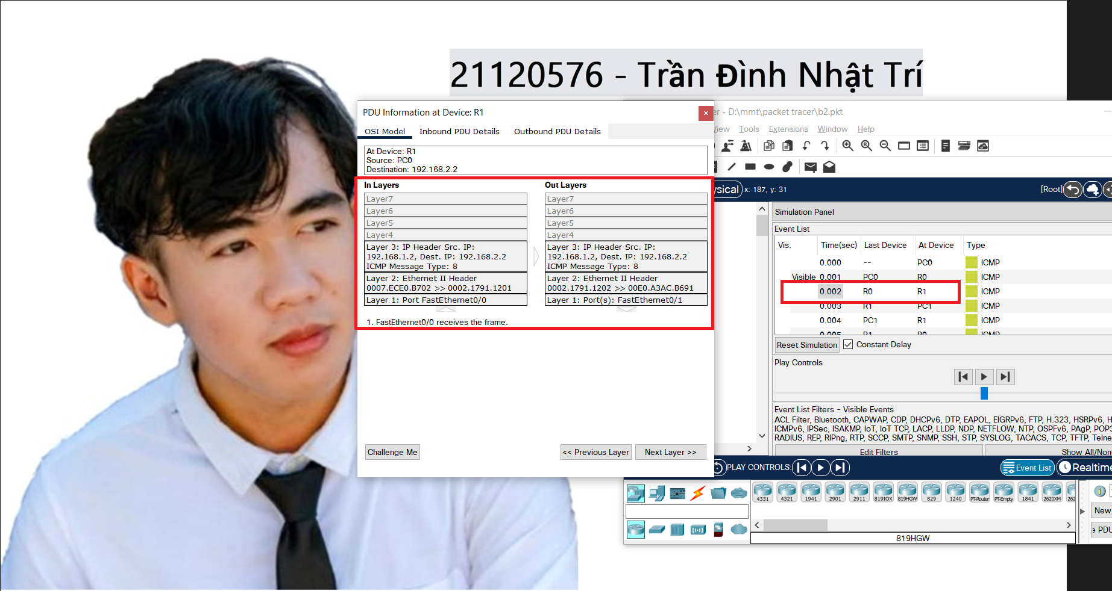

* **R1 -> PC1 (0.003):**

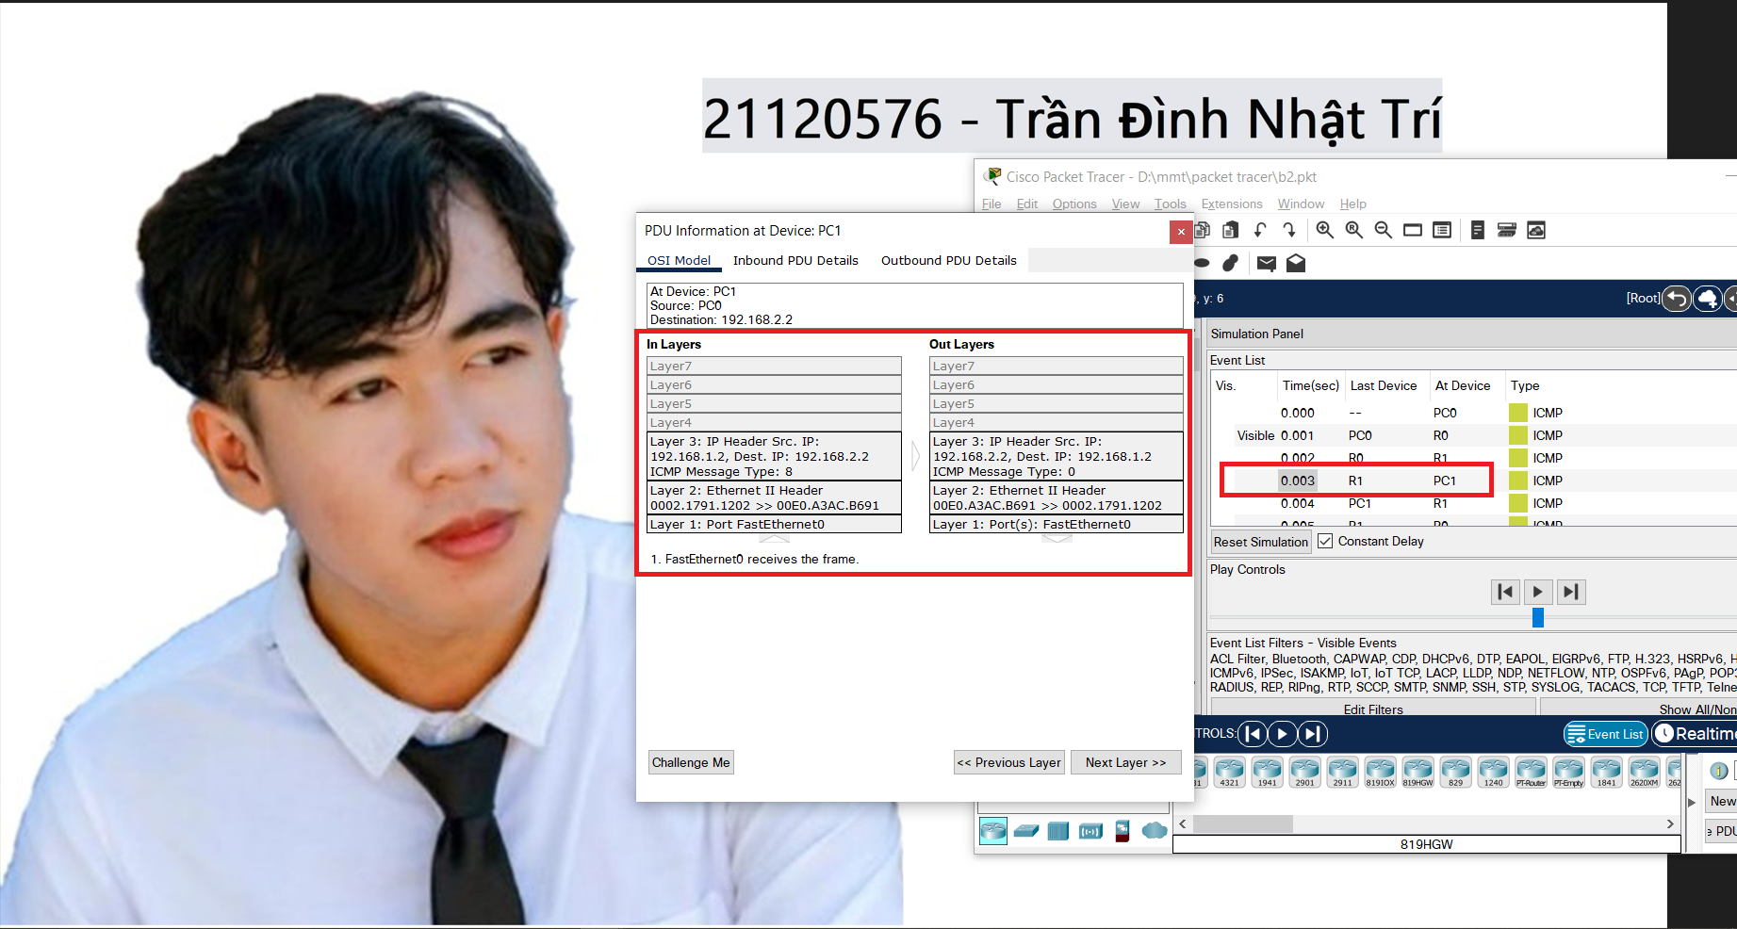

* **PC1 -> R1 (0.004):**

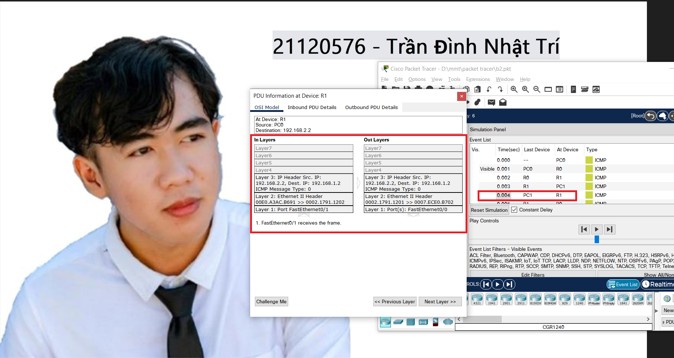

* **R1 -> R0 (0.005):**

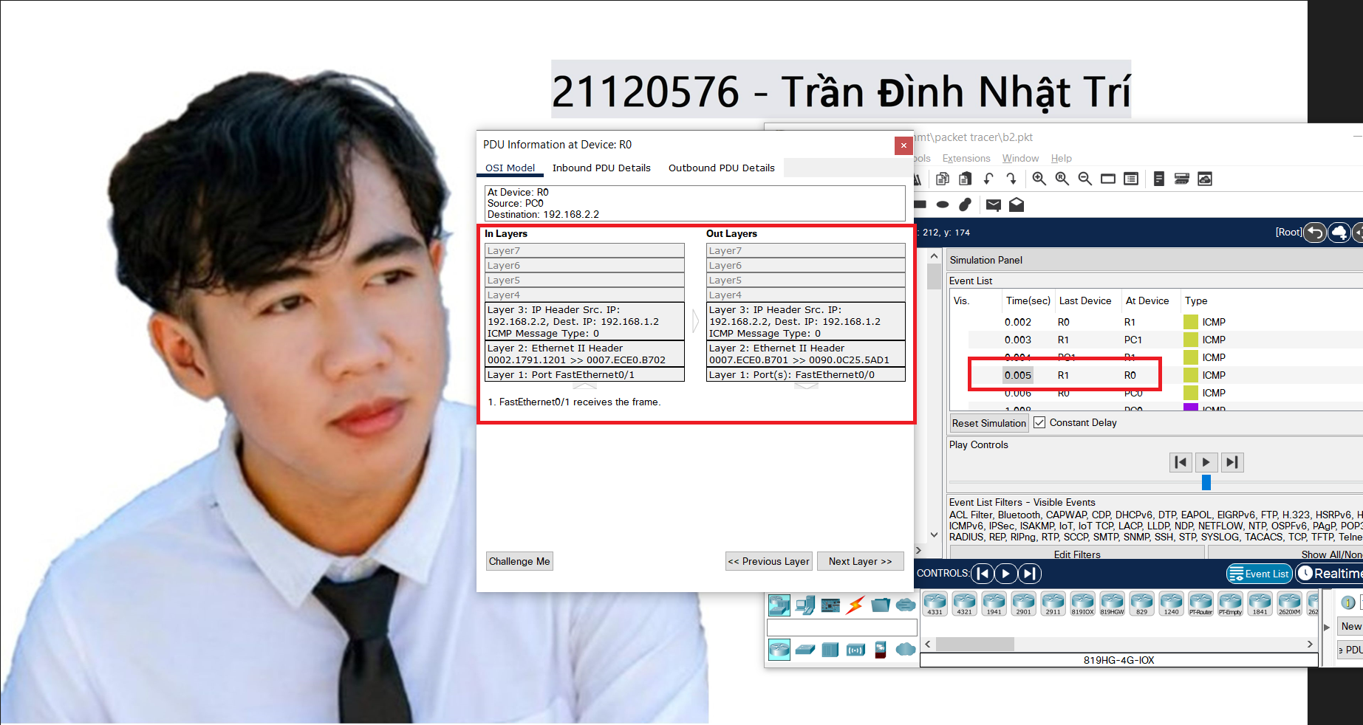

* **R0 -> PC0 (0.006):**

